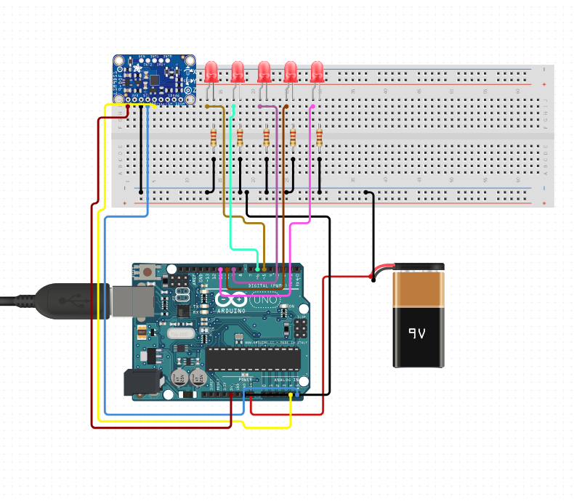

Block Diagram: <https://www.circuito.io/app?components=9590,9590,9590,9590,9590,10218,11021,779831>

Build Step By step guide:

https://www.circuito.io/static/reply/index.html?solutionId=5c3f87758499cb00308465d6&solutionPath=storage.circuito.io